DEAR Editor,

We like to thank the two referees’ constructive suggestions. Many efforts have been made to respond to their comments. They are summarized below.

- Add the motivation and goals of the study,
- Strengthen the discussion,
- Adding the references from the other research groups for contrasting the results,
- Improve the quality of almost all figures，
- The captions have been revised.
- Include the limitations of the study in the conclusion.

Please find our responses to each Reviewer’s comments.

Reviewer 1 Comments to the Author

1. Clarification regarding the user of the PMC chart (Figure 4 vs Figure 7)
The manuscript states that “In each shot, a Preferred Memory Colour (PMC) chart was presented as reference colors.” However, the PMC chart appears to be shown in Figure 7 rather than in Figure 4. Could the authors clarify why a color chart is not shown for Figure 4, and whether the PMC chart was indeed included in those captures? If it was included, it may be helpful to show it or explicitly explain the rationale for omitting it in Figure 4.
>> We have added the PMC chart to Figure 4, and revised Figure 8 to use real experiment image with no PMC chart.
The following paragraph is added after Figure 2:
For each model, two images were captured for each scene, inclusion and exclusion of PMC chart [14] respectively. The former was used to evaluate its white point to perform white balance and estimate the illuminance to serve as a reference when normalizing the skin color lightness for image rendering in the later stage. The latter was used in the real experiment.
2. Figure 13, interpretation of “preference centers” and connection to the text
I found Figure 13 somewhat difficult to interpret, particularly with respect to the “preference centers”. Additional explanations would help the reader understand how the figure supports the text. In Section 3.4.4 (“The Influence of Observer Familiarity with the Models on Skin Colour Preference”), multiple impression scales are plotted together, which makes the intended “preference centers” less clear.
>>The caption has been revised. It is now change to “Plots of the skin color centers of different impressions for the a) Asian, b) Caucasian, c) South Asian and d) African. The results are from the high luminance level of 6500K light source under in-lab condition.”
Also, the figure is replotted as follow. The original labelled markers have been replaced to improve readability.
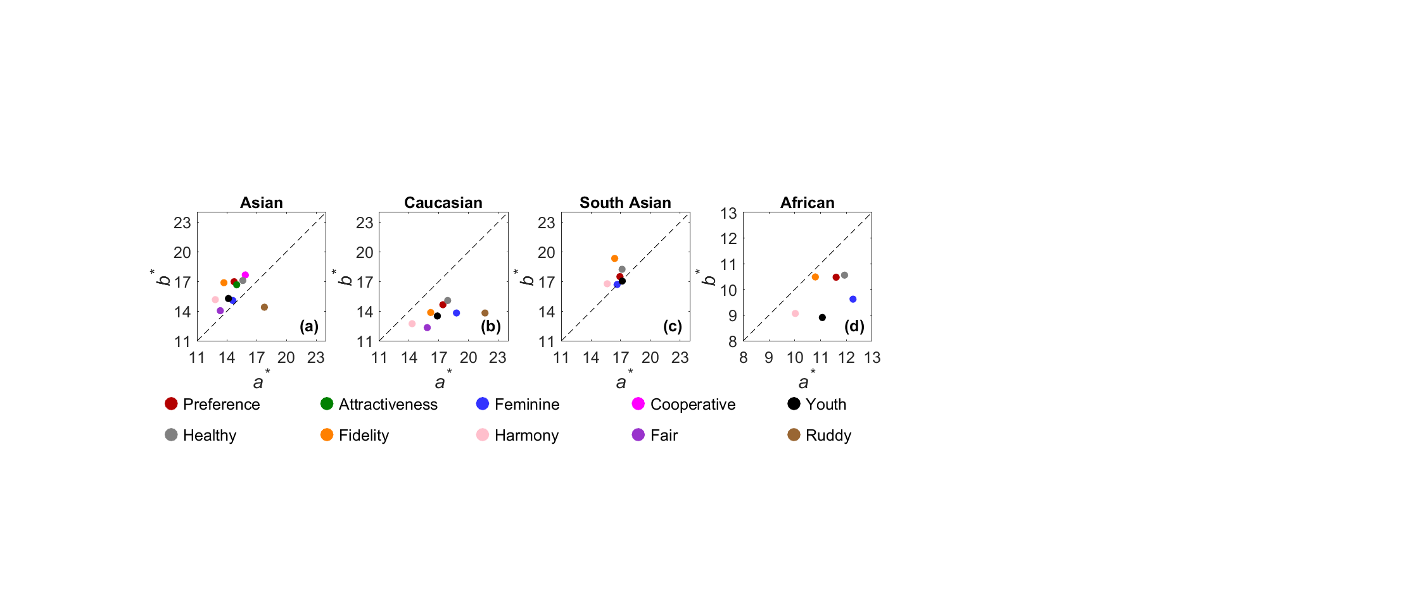
- Could the authors define what is meant by “preference centers” (e.g., a centroid of preferred samples, an optimal point estimated, or another construct)?
>> It is now impression centers, The panel observer’s impression centers are calculated by Equation as the centroid of the cluster.
where n is the number of the positive rendering points (pre-selected points with a p value higher than 0.5), a_{i} b_{i} are the coordinates of these positive points on a*b* plane, and p_{i} is the impression percentage (ratio of observers who give positive impression scores).
- It may also be helpful to more explicitly guide the readers by describing how to read the figure (e.g., what indicates higher preference, and how familiarity shifts the position/structure of the center).
3. Figure readability and resolution (e.g., Figure 15)
Some figures (most representatively Figure 15) would benefit from higher resolution and improved legibility. Increasing the font size of axes and labels and enlarging key elements (scales, markers, legends) could substantially improve readability. At present, several graphs are difficult to read comfortably.
>>Most of the figures have been redrawn and improved such as new figure 15.
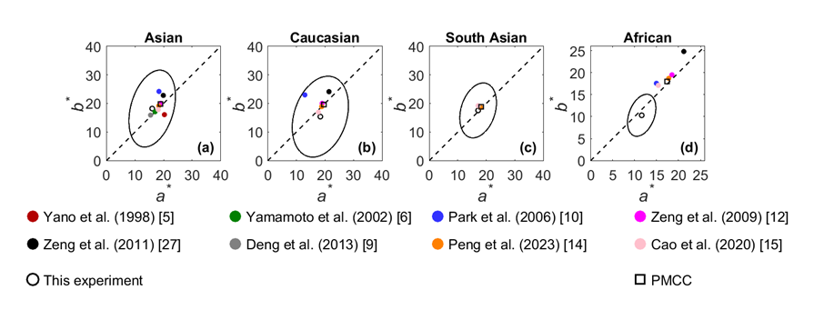
4. Section 4: novelty and positioning of the impression models and skin preference index.
My understanding is that Section 4 (Developing the impression models) aims to construct a skin preference index. To better position the contribution, it would be helpful if the authors clarify:
- Whether similar impression-based models or indices already exist in the literature, and how the proposed approach differs from or improves upon prior work
- Whether this is intended as a completely new model, or an extension/adaptation of existing frameworks. A brief comparison and clearer description of novelty would strengthen this section.
>> The model work is not unique. There are other researchers do it using neural network.
The current modelling work is incomplete and the work is still continuing. The present contents should be sufficient. We will publish the skin index model in the future.
5. Cross-referencing issues (references and equation links)
There appear to be several errors in cross-references (e.g., reference links and equation numbering links). I recommend that the authors carefully check the manuscript to ensure all references and equation citations are correctly linked and consistent.
>> These have been carefully checked..
6. Derivation of the adaptation factor coefficient 0.92
On page 22, in the procedure to calculate the skin preference index (step 2), the manuscript states: “To transform the image in XYZ from the shooting CCT to those under 6500K via CAT16 [25] using the incomplete adaptation factor (D) calculated through the equation of 0.92 × (1 – 500/CCT), which is derived from the present study.”
At present, it is unclear how the coefficient 0.92 was derived from the present study. Could the authors provide additional explanation or a short justification so that the readers can understand and reproduce this step?
>> We remove the D of 0.92 × (1 – 500/CCT part). However, we like to explain to the reviewer. We first find the white patch in the PMC chart and obtain an image’s RGB and calculate its XYZ for each image., We also like to transform them to the XYZ of D65 white. We can then minimize the DE value by keep changing D between each image’s white and D65 white.
This difference between values of 1 and 0.92 is small. So, we decide to remove it.
7. Depth of analysis and interpretation
While the experimental scope is broad and the results are clearly reported, the discussion currently reads as largely descriptive. I encourage the authors to expand the interpretation to better explain the implications of the findings (e.g., shy the observed effects occur, how they related to prior literature, and what practical insights can be drawn from imaging or display applications). Strengthening the discussion would improve the overall impact of the manuscript.
>> Expand the interpretation to the finding. We have improved substantially. The most important part is to add the goals in the research.
From the above survey, we can find only a few models’ skin colors based on independent factors, including impression, scene, gender and ethnicity. The present research is intended to perform a comprehensive investigation by simultaneously capturing the facial skin colors of models from different ethnicities across representative photographic scene conditions. The goals of the present study are fourfold:
- To examine the preferred skin colors of four ethnicities under different scene conditions;
- To understand the impact of skin color on 10 distinct impressions across the four ethnicities;
- To compare the preferred skin colors identified here with those reported in earlier studies; and
- To reveal the preferred skin colors between the stranger and acquaintance groups observers.

Overall, the work is promising and supported by a substantial dataset and experimental effort. Addressing the points above would, in my opinion, significantly improve clarity, reproducibility and the strength of the contribution.
>> Thanks to referee 1’s statement.

Reviewer 2 Comments to the Author

The engineering rigor in collecting the experimental images and establishing the acquisition setup is impressive. Beyond the “impression assessment” component, the resulting database could be valuable for a range of subsequent analyses. Overall, the authors appear highly experienced in conducting color experiments and the work is supported by appropriate equipment and careful technical procedures.
That said, I have several fundamental concerns regarding the manuscript’s research framing and the alignment between the stated goals and the analyses presented. While substantial effort has clearly been invested in materials, preparation, and evaluation, the manuscript does not yet demonstrate that these efforts directly advance the core research question. As written, the primary goal does not seem to be dataset construction itself, but rather to examine relationships between facial color (and/or ethnicity) and impression-related affective judgments. With that in mind, my comments are as follows.

Major points (conceptual framing and interpretation)
1. Motivation and relevance of the research question
The manuscript motivates the study by noting that few studies have systematically addressed the issue and that “familiarity has often been overlooked.” However, a gap in the literature alone is not sufficient justification. Please strengthen the argument for why the research question is important and timely, and clarify what specific theoretical or practical problem this study is intended to resolve.
>> We have added the motivation and goals of the work in the introduction section.
From the above survey, we can find only a few models’ skin colors based on independent factors, including impression, scene, gender and ethnicity. The present research is intended to perform a comprehensive investigation by simultaneously capturing the facial skin colors of models from different ethnicities across representative photographic scene conditions.
The goals of the present study are fourfold:
- To examine the preferred skin colors of four ethnicities under different scene conditions;
- To understand the impact of skin color on 10 distinct impressions across the four ethnicities;
- To compare the preferred skin colors identified here with those reported in earlier studies; and
- To reveal the preferred skin colors between the stranger and acquaintance groups observers.

2. Construct validity: isolating “skin color” effects from holistic face perception
A human face comprises multiple attributes (shape, texture, features, expression), and skin color is only one component. In real impression formation, observers do not assess “skin color” independently from other facial cues. Please clarify how you can be confident that the affective/impression judgments reported here are attributable primarily to skin color perception rather than to other correlated facial factors.
Relatedly, if “ethnicity” is a key variable, it would be helpful to define how it is operationalized in your study and how it is disentangled from other facial characteristics.

>> Strengthened that there are other parameters in addition yo the average skin color in section 1 as follow,
In addition to the above studies on average skin color in relation to preference or attractiveness, other impressions such as health, age, happiness, and upset have also been explored. Furthermore, color characteristics beyond average skin color have been found to influence facial perception. Lu et al. [16] investigated the impact of average skin color, local skin color, skin color variation, and facial color contrast on three key impressions: attractiveness, health, and age. They found that average skin color, together with color variation and contrast, strongly influences these facial impressions. Chinese observers were found to rely more on average skin color compared to Caucasian observers.
3. Interpretation: explaining the “why,” not only reporting the “what”
Currently, the manuscript focuses largely on reporting the outcomes of assessments from 20 observers. While this is a useful descriptive step, the paper needs stronger interpretation.
What mechanisms or perceptual/psychological explanations do you propose for the observed results? Even if causal claims are not possible, a discussion grounded in relevant literature is necessary to make the contribution meaningful as a research article.
>> Section 5 Discussion is added to summarized the findings and to compare with the earlier results.

4. Clarity of the overall experimental paradigm and section purpose
The technical descriptions of image collection and device characterization are clear; however, the overall study paradigm is not always easy to follow. In particular, Sections 2.2–2.4 (Experiment Design) read as a sequence of technical procedures, but the purpose of each subsection is not sufficiently explicit. Please clarify, for each subsection:
* What question/problem does this step address?
* Why is this step necessary for the final analyses and claims?
>> We have significantly simplified the part by drawing a workflow and explain the three key stages: camera, display characterization and image rendering in the following subsections.

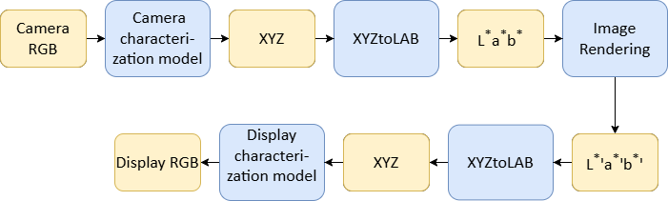
Figure 2. The workflow to prepare experimental images. The blue blocks are computation steps and yellow blocks are input and output data.
5. Suitability of the impression scales for the present study
You note that the 10 impression scales were developed in a prior study. Please provide a stronger rationale for why these particular scales are appropriate for evaluating “skin color–related” impressions in the current context. Based on your own discussion (e.g., Table 6), it appears that scale tuning or re-validation for this specific dataset/context may have been necessary. Please clarify whether the scales were validated for this study and, if not, why their direct reuse is justified.

>> Now we explain the 10 impressions in more details in the introduction section.

Wang et al. [17] explored how skin color affects 23 facial impressions using Chinese and Caucasian male and female images rated by 24 Chinese observers. Through factor analysis, they found that only five impressions, attractive, healthy, youthful, feminine, and cooperative—were sufficient to characterize facial perception. Liu et al. [18] extended this work by studying how skin color influences these five impressions and examining the color relationships among them. These findings are also incorporated into the present study. He et al. [19] studied the cross-cultural comparison on six terms, healthiness, preferences, brightness, whiteness, transparency and skin tones. They found cultural differences in that shifts toward reddish and yellowish skin colors produced positive impressions (more attractive, healthier) for Asian and Caucasian observers, respectively.

The references [18], [19] were added.

The impressions of ruddy, fidelity, harmony, fair, attractiveness were added by the professional photographers in the research team.
6. Presentation of the rendering pipeline and dataset output
Given that the dataset is a major asset of this work, the rendering and generation process (e.g., the 700 rendered images mentioned in Section 2.4) should be presented more clearly and concretely. Consider adding a compact overview figure/table summarizing:
* Inputs (original images, capture conditions)
* Processing steps (rendering/normalization)
* Outputs (final image set and metadata)

>> >> Thanks for the advice. See above 4).
7. Discussion is currently insufficient
Excluding the Conclusion, the manuscript effectively ends with correlation analysis results. At present, the paper reads more like a technical report than a research article because it stops at reporting procedures and statistics. A dedicated Discussion section is needed to articulate:
* How they compare with and extend prior work
* Limitations (especially regarding confounds in face perception)
* Implications and next steps (including how others may reuse the dataset)
>>The current modelling work is incomplete and the work is still continuing. We have decided to remove this part. The present contents should be sufficient. We will publish the skin index model in the future.
>> A summary of the future work are given in conclusion.
- Same experiment can be conducted by using other ethnicity groups or different professionals, such as cosmeticians, photographers.
- Further analysis can be performed on the other impressions rather than heavily focused on preference.
- Models can be developed to predict many impression skin color center, to evaluate the skin quality based on conventional or neural network methods. It can also be used to estimate the quality of preferred skin colors. The data should be modelled to develop the quality of each impression.
- The present data largely disagree with the earlier studies on African preferred skin color. We should intensive study the African skin preferred colors to understand the causes of the huge discrepancy between the present and the other studies.
- The data can be used to develop the preferred skin chart as a calibration target for camera.

8. Analysis choices: averaging impression scales before analysis (Table 9)
Please explain the rationale for averaging the 10 impression scales prior to analysis. These scales appear to represent distinct dimensions of impression; averaging them may obscure meaningful differences and reduce interpretability. If a composite score is intended, please justify it (e.g., via factor analysis, reliability metrics, or a theory-driven argument).
Additional points (presentation and polish)
>> Please see the reply in the last comment.
9. Reference balance and self-citation
As you are aware, this review is not blinded. I noticed that a substantial portion of the references (13 of 33) are authored by the corresponding author. Even if many are relevant, the proportion feels excessive and may unintentionally weaken perceived objectivity. Please consider broadening the citation base to better represent the wider literature.
>> We add some important other people’s references, i.e. Lu [16] , Liu [18], He [19], and Pauker [20].
10. Tables and captions need more self-contained information
Several tables (e.g., Tables 3, 4, and 7) would benefit from clearer units and definitions (e.g., scale ranges, score units, and what higher/lower values indicate).
More generally, the Results section includes many tables/figures/equations, but some are presented with limited explanation. For example, the caption and accompanying text for Table 8 should clarify precisely what is being averaged and compared (e.g., hue angles of preferred skin color between in-lab vs. real-scene) and why this comparison matters.
>> We have revised the definition of each column. Also, all captions of tables and figures have been rewritten.
11. Minor issues
I noticed some typographical and formatting errors (e.g., a broken link). Please carefully proofread the manuscript.
>> We have improved most of them.

